Multiple-choice section

|  |  |  |  |  |  |  |  |  |
| --- | --- | --- | --- | --- | --- | --- | --- | --- |
| Question | 1 | 2 | 3 | 4 | 5 | 6 | 7 | 8 |
| Answer | C | B | D | D | C | B | B | A |

Question 1 [8.1]

B

Greater than 90° and less than 180°is an obtuse angle.

Question 2 [8.1]

C

Co-interior angles on parallel lines are supplementary (add to 180°)

Question 3 [8.4]

A

Both triangles have a right angle. Also share the hypotenuse and have one side equal.

Therefore, they are congruent by Right angle, Hypotenuse, Side (RHS).

Question 4 [8.2]

B

*x* + 60° + 80° + 80°= 360°

*x* + 220°= 360°

*x* = 140°

Question 5 [8.3]

C

Reflection, translation and rotation are all transformations; orientation is not.

Question 6 [8.2]

C

Isosceles triangle has a pair of angles equal.

Question 7 [8.2]

A

Hexagon has 6 sides, octagon has 8 sides and dodecagon has 12 sides. Decagon has 10 sides.

Question 8 [8.5]

A

Multiple-choice total marks: 8

Short answer section

Question 9 2 marks [8.2, 8.3]

(a) The exterior angle of a *triangle* is equal to the sum of the two opposite interior angles.

(b) Another name for a flip is a *reflection*.

Question 10 2 marks [8.1]

(a) 42° + 48° = 90° (complementary angles add to 90°)

(b) 15° + 165° = 180° (supplementary angles add to 180°)

Question 11 4 marks [8.5]

*x* = 112° (opposite angles in a parallelogram are equal)

*y* = 32° (angle *ACB* = angle *CAD* in congruent triangles, or alternate angles)

*z* = 180° – 112° – 32°

*z* = 36° (angles in a triangle add to 180°)

Question 12 4 marks [8.1]

(a) *x* + 85° = 360°  
*x* = 275° Reason: angles in a revolution add to 360°

(b) *x* + 90° + 43° = 180°   
*x* = 180°- 133°  
*x* = 47° Reason: angles on a straight line add to 180°

Question 13 2 marks [8.1]

*AB* || *CD*

∠*AGE* = 45° (given)

∠*AGE* = ∠*GHC*

∠*GHC* = *x* = 45° Reason: corresponding angles on parallel lines are equal

Question 14 2 marks [8.1]

*a* = 110° Reason: vertically opposite angles

Question 15 4 marks [8.2]

(a) 70° + *y* + *y* = 180°  
2*y* = 180° – 70°  
*2y* = 110°  
*y* = 55° (angle sum of a triangle)

(b) 115° + 115° + *w* + *w* = 360°  
230° + 2*w* = 360°  
2*w* = 130°  
*w* = 65° (angle sum of a quadrilateral)

Question 16 3 marks [8.2]

(a)

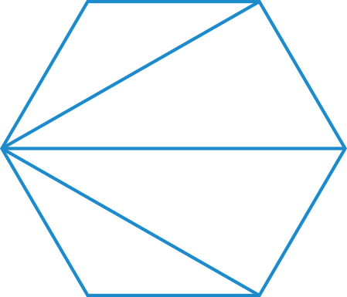

There are 4 triangles.

(b) 4 × 180° = 720°  
The angle sum of a hexagon is 720°.

Question 17 6 marks [8.3]

(a) [-4, -8] means slide 4 units to the left and 8 units down.

(b)

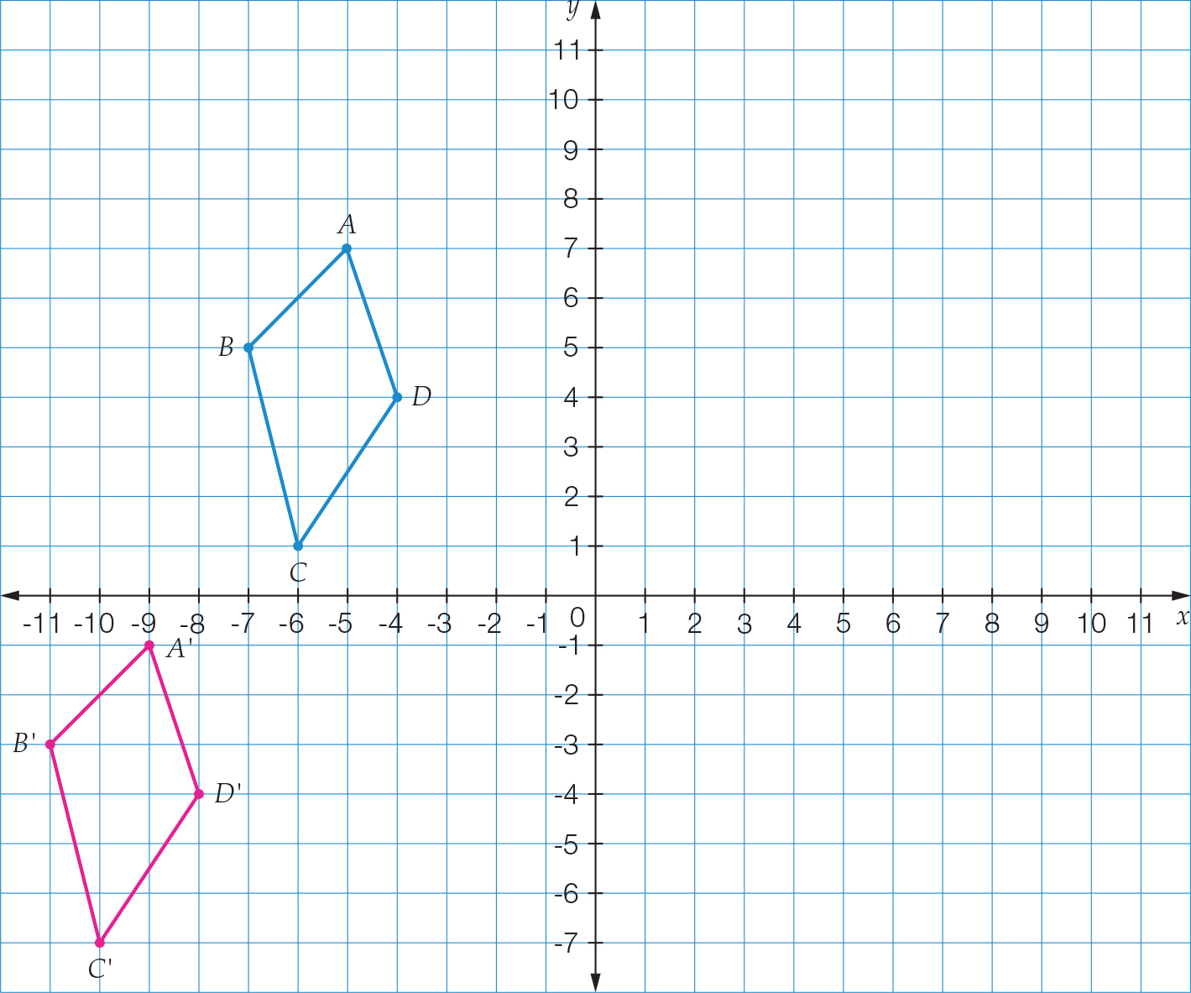

(c) *A*' (-9,-1), *B*' (-11, -3), *C*' (-10, -7), *D*' (-8, -4)

Question 18 6 marks [8.3]

(a)

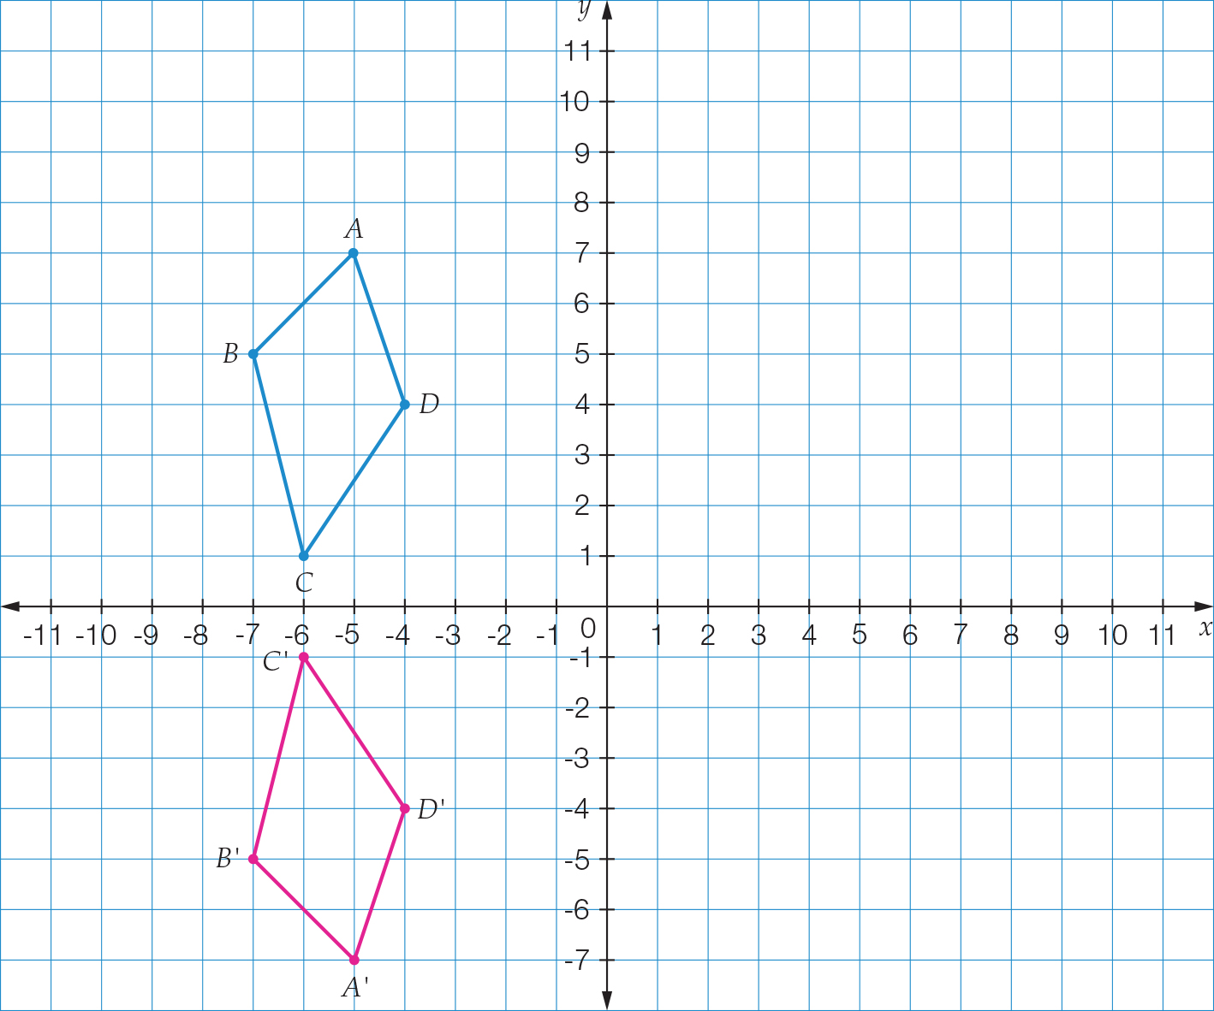

(b) *A*' (-5, -7), *B*' (-7, -5), *C*' (-6, -1), *D*' (-4, -4)

Question 19 2 marks [8.5]

∆*PQR* ≡ ∆*PSR*

∆*SPQ* ≡ ∆*SRQ*

Question 20 2 marks [8.5]

*x* = 5 m

*y* = 116°

Question 21 2 marks [8.4]

Left and right triangles are congruent and are isosceles triangles.

Top and bottom triangles are congruent and are isosceles triangles.

*x* = 68° (base angles of an isosceles triangle)

Short answer total marks: 41

Extended answer section

Question 22 4 marks [8.2]

|  |  |
| --- | --- |
| (a) 4*x* + 12° + 3*x* + 40° + *x* = 180° 8*x* + 52° = 180° 8*x* = 128° *x* = 16° (angle sum of a triangle) | (b) 4*x* + 12° = 4 × 16° + 12° = 76° 3*x* + 40° = 3 × 16° + 40° = 88° *x* = 16° |

Extended answer total marks: 4

TOTAL test marks: 53